Review Paper

**Topic:** Visible Light Communication

Course Title: Data Communications

Course Code: CSE 303

Submission Date: 06/05/2024 [dd/mm/yyyy]

**Team Members**

Jahidul Islam (21201197)

Sadman Bin Khorshed Amio (21201201)

Taraq Aziz Tanvir (21201203)

Fahmy Islam (21201208)

**Submitted to,**

Dr. Muhammad Towfiqur Rahman

Assistant Professor

Department of CSE

University of Asia Pacific

**Contents**

1. Abstract………………………………………………………..3
2. Introduction………………………………………………….3-5
3. System Overview
   1. LEDs…………………………………………………...6
   2. Types of LEDs……………………………………… 6-8
   3. VLC vs RF……………………………………………8-9
4. Communication Architecture
   1. Overview……………………………………………. 9-10
   2. Transmitter…………………………………………….. 10
   3. Receiver……………………………………………….. 10
   4. VLC Standards………………………………………10-11
   5. Network Topology…………………………………..11-12
5. Physical and MAC Layer
   1. Physical Layer………………………………………13-14
   2. MAC Layer………………………………………….15-16
6. VLC Application
   1. Indoor VLC System…………………………………….16
   2. Vehicular Communication……………………………...16
   3. Indoor Positioning System……………………………...16
   4. Underwater Communication……………………………17
7. Challenges
   1. Line of Sight (LOS)……………………………………..17
   2. Flickering………………………………………………..17
   3. Noise and Interference…………………………………..18
   4. Dimming………………………………………………...18
   5. Mobility…………………………………………………18
8. VLC Research Platform
   1. Shine…………………………………………………….18
   2. modBulb………………………………………………...18
   3. iDropper…………………………………………………19
   4. Darklight………………………………………………...19
9. Advantages & Disadvantages
   1. Advantages……………………………………………...19
   2. Disadvantages……………………………………….19-20

10. Conclusion & Discussion…………………………….20

11. Comparison Table……………………………………20

12. Reference………………………………………….21-25

**Visible Light Communication (VLC)**

1. **Abstract**

Visible Light Communication (VLC) has emerged as a cutting-edge technology revolutionizing wireless communication paradigms. This review paper provides a comprehensive analysis of VLC, exploring its principles, applications, challenges, and future prospects. Beginning with an introduction to VLC and its significance in modern communication systems, the paper delves into the fundamental principles of VLC, including modulation techniques and system components. It examines the advantages of VLC over traditional radio frequency (RF) communication, such as higher data rates, improved security, and immunity to electromagnetic interference.

The review highlights a diverse range of applications where VLC demonstrates its versatility, including indoor positioning, Li-Fi for high-speed data transmission, and underwater communication. Real-world examples underscore the practical implementation and efficacy of VLC solutions across various domains. Despite its promising capabilities, VLC faces challenges such as limited coverage range and susceptibility to ambient light interference. Ongoing research efforts to address these challenges and enhance VLC performance are discussed, along with standardization initiatives and regulatory considerations.

One cool thing about LEDs is that they can quickly change their light intensity. This has led to a new Visible Light Communication (VLC) technology. With VLC, we can use LED lights to

Transfer data at high speeds.

This paper talks about VLC and how it works. It covers:

1. The VLC system and its parts like the transmitter and receiver.

2. The properties of the VLC channel, different ways to modulate the light, and techniques

to use multiple inputs and outputs (MIMO).

3. How devices can share the VLC medium.

4. How to design a VLC system and the platforms that can be programmed for it.

5. VLC’s uses in sensing, like figuring out where you are indoors, recognizing gestures,

communicating between screens and cameras, and networking between vehicles.

The paper also points out challenges that need to be solved to make VLC work well in high-

speed mobile networks.

1. **Introduction**

In telecommunications, visible light communication (VLC) is the use of visible light (light with a frequency of 400–800 THz/wavelength of 780–375 nm) as a transmission medium. VLC is a subset of optical wireless communications technologies.

Indoor lighting is going through a revolution. The incandescent bulb has been widely used to lit our surroundings since its invention over a century ago is slowly being phased out due to its extremely low energy efficiency. Even in the most modern incandescent bulbs, no more than 10% of the electrical power is converted to useful emitted light. The compact fluorescent bulbs introduced in the 1990s have gained increasing popularity in the last decade as they provide better energy efficiency (more lumens per watt). However, recent advancements in solid-state lighting through Light light-emitting diodes (LEDs) have enabled unprecedented energy efficiency and luminaire lifespan. The average luminous efficacy (how much electricity is used to provide the intended illumination) of best-in-class LEDs was as high as 113 lumens/watt in 2015 [1], and is projected to be around 200 lumens/watt by the year 2020. This is a many-fold increase compared to current incandescent and fluorescent bulbs which provide an average luminous efficacy of 15 and 60 lumens/watt [1] respectively. Similarly, the lifespan of LEDs ranges from 25 000 to 50 000 hours significantly higher than compact fluorescent (10 000 hours). Apart from the energy savings and lifespan advantages, the LEDs also have other benefits like compact form factor, reduced usage of harmful materials in design, and lower heat generation even after a long period of continuous usage. Due to these benefits, LED adoption is on a consistent rise and it is expected that nearly 75% of all illumination will be provided by LEDs by the year 2030 [1]. LEDs (Light Emitting Diodes) are becoming more popular. They’re different from old lighting technologies because they can change their light intensity very quickly. This change is so fast that we can’t see it with our eyes. This feature can be used for communication by encoding data in the light they emit. A light sensor or an image sensor can receive these signals and decode the data. This means LEDs can be used for both lighting and communication.

In recent years, research into this Visible Light Communication (VLC) has shown it can achieve very high data rates. It’s especially important when compared to existing wireless communications. With the increase in mobile data traffic, the current RF spectrum is becoming too crowded. But the visible light spectrum, which includes hundreds of terahertz of license-free bandwidth, is completely untapped. VLC also has other advantages. Because visible light can’t go through most objects and walls, you can create small cells of LED transmitters without worrying about interference from other cells. This also provides security, as the signals can’t penetrate walls. Plus, VLC can use existing lighting infrastructure, so it’s cheaper and easier to set up. This potential of VLC is why this survey was compiled.

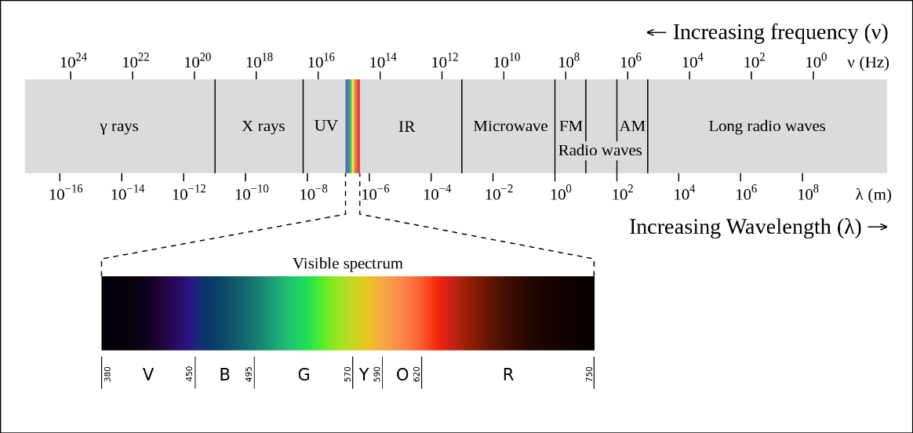

Fig-1: The Human eye can perceive the electromagnetic signals between the frequency range of

430 THz and 790 THz which is referred to as the visible light spectrum.

The pioneering efforts of utilizing LEDs for illumination as well as communication date back to year 2000 when researchers [2] in Keio University in Japan proposed the use of white LED in homes for building an access network. This was further fueled by rapid research, especially in Japan, to build high-speed communication through visible light with the development of VLC support for hand-held devices and transport vehicles. This led to the formation of the Visible Light Communications Consortium (VLCC) [3] in Japan in November of 2003. VLCC proposed two standards—Visible Light Communication System Standard and Visible Light ID System Standard—by 2007. These standards were later accepted by Japan Electronics and Information Technology Industries Association (JEITA) [4] as JEITA CP-1221 and CP-1222 respectively. The VLCC also incorporated and adapted the infrared communication physical layer proposed by International Infrared Data Association (IrDA) [5] in 2009. In parallel, the hOME Gigabit Access project (OMEGA) [6], sponsored by the European Union, also developed optical communication as a way to augment the RF communication networks. In 2014, VLCA (Visible Light Communications Association) [7] was established as a successor of VLCC in Japan for further standardization of VLC. The first IEEE standard for visible light communication was proposed in 2011 in the form of IEEE 802.15.7 [8] which included the link layer and physical layer design specifications. In last couple of years, the achievable VLC link capacity has surpassed 1 Gbps, and increasing research efforts are being directed towards realizing the full potential of VLC. In this survey, we provide a systematic view of VLC research and identify important challenges. Specifically, we provide a technology overview and literature review of

1) Visible light communication system components and, details of transmitter and receiver characteristics,

2) Physical layer characteristics such as channel model and propagation, modulation and coding schemes, and Multiple-Input Multiple-Output (MIMO) techniques,

3) Link layer, multiple user access techniques, and issues,

4) System design and various programmable VLC platforms,

5) Visible light sensing and applications such as visible light indoor localization, human-computer interaction, device-to-device communication, and vehicular communication applications.

1. **VLC System Overview**

The use of wireless optical communication has become very popular in recent years. In particular, studies involving the visible light spectrum are increasingly common, since this area has a great academic and commercial potential [33]. Visible Light Communication includes all the frequencies of the visible light spectrum, that is, waves ranging from 430 THz to 790 THz [21].

(3.1) **LEDs** **A Great Opportunity for VLC:** Several factors contributed to the growing interest in VLC. Among all, what stands out most is the use of LED for the manipulation of light waves. Due to its characteristics such as price, LED light bulbs have become the main medium used for Visible Light Communication. In addition, LED light bulbs became increasingly popular, integrating various environments where it would be advantageous to use light as a form of communication. Therefore, it is common to choose this type of light bulb in VLC [15] systems. The LED (Light Emitting Diode) is a device that uses electroluminescence and semiconductors in order to generate light. More specifically, LEDs are made of materials that are partly capable of conducting current. Additionally, light is emitted when the electric current passes through the material, a phenomenon known as electroluminescence. This happens due to the existence of electron holes (when an atom lacks electrons) between two semiconductors. Therefore, when electrons flow through it, they fill the electron holes, and consequently, they emit photons. The light is emitted in the visible spectrum, which varies from low to high-frequency waves, corresponding to a specific color. Red LEDs, for example, are commonly made of gallium arsenide phosphide (GaAsP), and their wavelength varies from 630 nm to 660 nm.

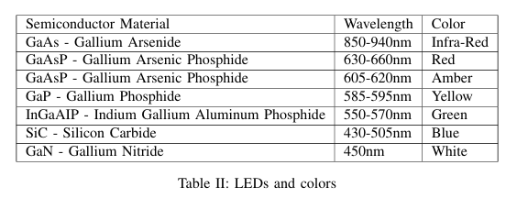

Table II presents some colors and their respective semiconductor materials, as well as the wavelength of the emitted light. There are many reasons behind the exponential growth of LED bulbs nowadays. Some well-known advantages of this type of light source are energy efficiency, durability, and low cost. Residential LEDs use at least 75% less energy and can last 25 times longer than a traditional incandescent light bulb. In addition, it is possible to focus the light of an LED bulb in a single direction. Due to these advantages, LED bulbs are used in various devices, such as smartphones, vehicles, video screens, and signs, and are present in many applications, including Visible Light Communication.

(3.2) **Types of LEDs:** White LED light bulbs are the most common type these days. They're made in two main ways. The first way is by using a blue LED bulb that's covered with a layer of phosphor. The blue LED creates photons (light particles) that pass through the phosphor layer. Some of these photons turn yellow. When the yellow and blue photons mix, they create white light. You can see how this works in Figure 4.

The second way to make white LEDs is by using red, green, and blue LEDs (RGB LEDs) and mixing their light together. This kind of white LED lets you control the color of the light. Both methods have their pros and cons. Generally, the phosphor method is more popular for LED light bulbs because it's cheaper and more efficient. But for Visible Light Communications (VLC), the RGB bulb is often better because it lets you control the light more. The IEEE standard for VLC [12] even has a method that only uses the intensity of the RGB LED.

LEDs are semiconductors made to be light sources. But they can also work as sensors, converting light into electricity. This isn't very well-known but is becoming more popular in VLC research. LEDs can act as receivers because when light hits the LED, it creates a small current that's proportional to the light's intensity. This is called photocurrent [49]. While a photodiode can detect a wide range of light (including ultraviolet and infrared), an LED is more selective and detects a narrower range of wavelengths. Generally, an LED can detect the same or higher frequencies of light that it emits [50]. So a red LED could detect red, green, and blue light, but a blue LED would only detect blue light. Shin et al. studied 4 different types of LEDs and how they emit and respond to light [51], as shown in Figure 5. But in practice, this might not always be the case. The light that LEDs can detect may vary depending on the light they emit. Usually, in the visible spectrum, the detection shifts slightly towards blue (higher frequencies). But green, for example, has a very narrow detection band, different from the light it emits. So a green LED might not detect green light. In [52], the authors studied how different colors affect LED-to-LED communication. They used multiple colors as transmitters and receivers to cover the whole spectrum. They also looked at how distance affects performance.

There are many types of LEDs, each with its own special features, which makes them good for VLC applications. The light they emit depends on the material used to make the chip. This means the photon (light particle) will have a specific wavelength, which gives it a color. Gallium Arsenide (GaAs) and Gallium Phosphide (GaP) are examples of compounds used in LEDs. The main types of LEDs are listed below, along with their details.

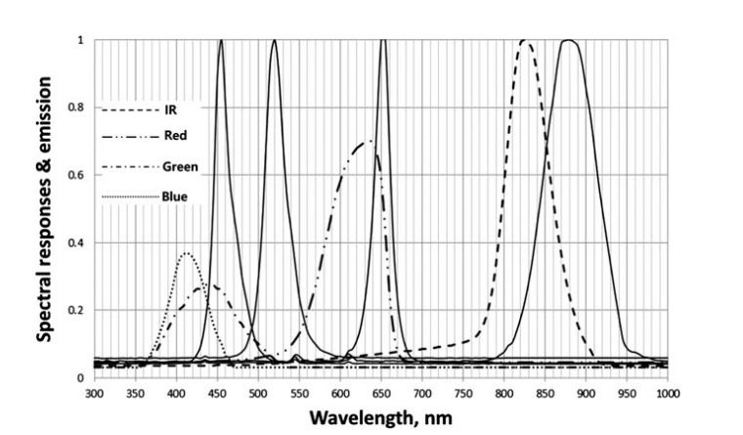

Figure 5: Spectral response of 4 different LED types [51].

**Phosphor Converted LEDs (pc-LEDs):** These are common and not too complicated or expensive. They're made from a blue LED chip that's covered with a layer of phosphor. This layer changes some of the blue light to green, yellow, and red. Some of the blue light is also let out. Together, this makes white light. But this type of LED has a limited range because phosphorus responds slowly.

**Multi-chip LEDs:** This type of LED is made up of three or more chips that each emit a different color of light. Usually, they emit red, green, and blue (RGB) to make white light. The big advantage of this type is that you can control the colors it emits by changing the intensity of each chip. There's a special way to change the colors called Color-Shift Keying. You can find more details about this in Section IV.

**Organic LEDs (OLEDs):** These LEDs are made from a series of thin organic films between two conductors. When you apply an electric current, they emit light. They're often used in smartphone displays. The big advantage of this technology is that you can make transparent and flexible devices with it. But in terms of frequency and durability, OLEDs are still not as good as other types of LEDs [15].

**µ-LEDs:** These LEDs are usually used in displays, allowing for high-density parallel communication at very high speeds.

(3.3) **VLC versus RF:** (Advantages and Disadvantages)

In recent decades, communication technologies have made significant progress. In wireless communication, Wi-Fi has become the main way to access the Internet. However, issues such as the Wi-Fi spectrum crisis and the high demand for wireless connections drive the need for new technologies and research. VLC studies mainly focus on using VLC as a complement to Wi-Fi to meet the current demand for wireless bandwidth [53]. Some researchers also suggest using VLC as a replacement for Wi-Fi in certain scenarios [23]. In both cases, the pros and cons of VLC compared to Wi-Fi should be considered.

One major benefit of VLC is the use of existing infrastructure for communication services. LED light bulbs, which are already widely used for lighting, can also transmit data through light. This way, the energy used for communication doesn't increase costs [54]. Additionally, recent research has focused on using low-cost devices to implement VLC systems. For example, Wang and colleagues used microcomputers (Beaglebone) and affordable LEDs to create an open-source platform for VLC studies [55]. Another important work comes from Disney Research Center, which developed a VLC system using commercial LEDs [56].

A key advantage of visible light is the large size of its spectrum compared to radio frequency. Radio frequency bands are heavily regulated by each country and managed by international telecommunication authorities. Each country sets its own regulations for different types of use, ranging from military purposes to AM and FM radio broadcasts. Wi-Fi devices use two bands: 2.4 GHz and 5 GHz, which are meant for unlicensed devices. However, the visible light spectrum is entirely free, opening up many opportunities for commercial and academic use [54]. Despite these possibilities, visible light is susceptible to interference from other light sources, both artificial (other LEDs, incandescent and fluorescent bulbs) and natural (sunlight). This can pose challenges for VLC systems, but researchers are working to address these issues (discussed further in section VI).

Light's propagation properties offer security advantages over radio waves. When a Wi-Fi access point is set up, radio waves can travel long distances and pass through walls and other solid surfaces, potentially posing a security risk due to eavesdropping [54]. Light, on the other hand, doesn't behave this way. Its waves can't penetrate walls or other surfaces, providing a safer environment where the transmitted data is limited to what can be seen [57]. This ability to control light waves is another major advantage of VLC.

Finally, one of the greatest advantages of using light for communication is its high wave frequency (in the THz range), allowing for very high data rate communication. The highest data rate achieved with Wi-Fi is around 1 Gbps in the WiGig standard [58]. However, VLC research has already reached impressive speeds of 100 Gbps [59], [60].

1. **Communication Architecture**

VLC systems consist mainly of two key components: a transmitter and a receiver. These systems often involve customizing three layers of the protocol stack [66]: physical, link, and application layers. Researchers often discuss these layers when explaining the architecture of VLC systems [32]. In this section, we will first cover an overview of these three layers. Then, we will talk about the network topologies and challenges, like mobility [66]. Lastly, we will discuss the different devices mentioned in the literature and how they are adapted for specific scenarios, such as indoor network topologies that complement Wi-Fi [67].

(4.1) **Overview**

Visible Light Communication (VLC) uses light to send information. VLC aims to provide lighting and communication at the same time. Therefore, VLC systems always have components that can transmit and receive light. Most work in the literature uses LEDs as transmitters, modulating the light's intensity to send data. On the receiver side, photosensors capture this light directly and convert it into a data stream [16]. It's important that the lighting brightness is not affected while transmitting information, so the type of LED used impacts VLC system performance.

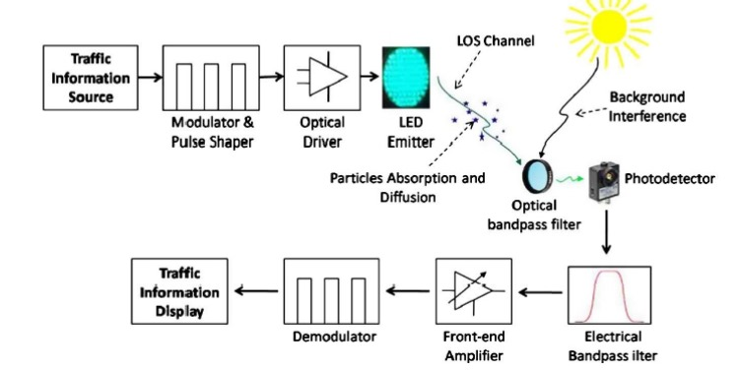

Figure 8: VLC System Architecture, adapted from [68]

Figure 8 provides an overview of the architecture of a VLC system. LEDs transmit data using Intensity Modulation. The receiver must have a direct line of sight with the LED to receive the light signals containing information. During light transmission, there can be a loss in light signal quality due to light scattering and interference from ambient light. Filters may be used to minimize interference. At the receiver node, the light hits the photosensor, directly affecting the current. Amplifiers help make the signals less prone to interference and noise [56]. Finally, the signal is demodulated to retrieve the original information. Below, we describe each component of a VLC system in detail.

(4.2) **Transmitter**

Typically, LEDs serve as transmitters in VLC systems. Most light bulbs available on the market contain multiple LEDs. These bulbs include a driver that controls the current flowing through the LEDs, impacting the intensity of the light. In other words, transistors regulate the current reaching the LEDs, allowing the LED to emit light signals at high frequency for communication that is undetectable to human eyes [21].

(4.3) **Receivers**

Receivers capture light and convert it into electrical current. Usually, photodiodes are used as receivers in VLC systems [56]. However, photodiodes are very sensitive and can detect waves beyond visible light, such as ultraviolet and infrared [55]. They can also easily saturate in outdoor environments with sunlight, causing them to fail to receive data due to high interference. Therefore, other devices can capture light as well, including smartphone cameras, which enable any cell phone to receive data from a VLC transmitter (as discussed in Section II). Besides these devices, LEDs themselves can be used as receivers due to their photo-sensing capabilities [63].

Unlike photodiodes, LEDs can detect a smaller frequency range, which reduces noise and interference. Additionally, LEDs' sensitivity remains stable over time. A major advantage of LEDs is their ability to function as both transmitters and receivers, allowing a system to use only one LED at each point. Furthermore, they are popular and affordable components, making VLC applications more user-friendly.

(4.4) **VLC Standards**

The standardization of Visible Light Communication began in 2003 with the creation of the Visible Light Communication Consortium (VLCC) in Japan. Research on VLC was already underway worldwide, including in Japan where VLC-based positioning was being explored. In 2007, two standards, JEITA CP-1221 (covering the basics of VLC systems) and JEITA CP-1222 (a standard for Visible Light ID Systems), were introduced by the Japan Electronics and Information Technology Industries Association (JEITA) [69].

As VLC gained popularity in universities and industry, the need for standardization arose. In 2011, the IEEE 802.15.7 Visible Light Communication Task Group released the IEEE 802.15.7 standard, which defines the physical and MAC layers for short-range wireless optical communication using visible light [12]. The standard ensures data delivery rates that support services like multimedia and audio, while also considering the impact of VLC on health and the environment. It covers network topologies, device types for VLC, communication architecture, physical layer characteristics, MAC layer support for dimming and flickering, and security specifications.

The standard addresses different device types in VLC systems, such as infrastructure, mobile, and vehicular devices, each with its own features as detailed in Table IV. It specifies topologies and modulation methods for VLC systems.

Most of the IEEE 802.15.7 standard focuses on physical and MAC layer characteristics (see Section IV). The standard divides the physical layer into three operation modes: PHY I, PHY II, and PHY III. Systems must implement at least PHY I or PHY II, while systems using PHY III must also support PHY II.

- *PHY I* is designed for outdoor applications with short frames and supports data rates from 11 kbps to 266 kbps.

- *PHY II* supports data rates from 1.25 Mbps to 96 Mbps.

- *PHY III* supports data rates from 12 Mbps up to 96 Mbps and uses a modulation scheme for multi-chip LEDs.

Tables V, VI, and VII outline details for each mode of operation, including supported modulations and encodings.

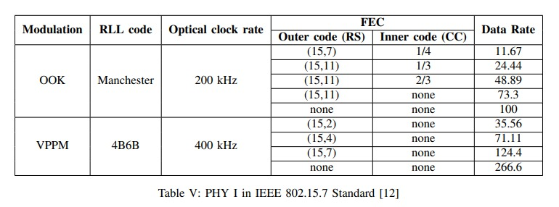

The standard covers dimming and flickering to allow manipulation of light intensity without affecting communication. Security is also addressed, as light offers different properties than radio waves, enabling detection of unauthorized interception of the signal. The proposed cryptographic mechanism uses symmetric keys generated by upper layers and offers services such as confidentiality, authenticity, and replay protection.

(4.5) **Network Topologies**

In a computer network, the network topology explains how devices are organized and how they share information [70]. It can be described both logically and physically. Common topologies in computer networking include Peer-to-Peer, Bus, and Ring.

This concept is similar in VLC systems. According to the official VLC standard [12], there are three types of devices considered for VLC: infrastructure, mobile, and vehicular (Table IV). The IEEE 802.15.7 standard defines three topologies for VLC applications: peer-to-peer, star, and broadcast, as shown in Figure 9.

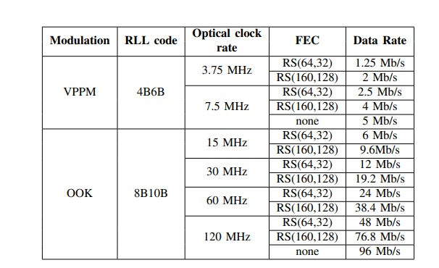

Table VI: PHY II in IEEE 802.15.7 Standard [12]

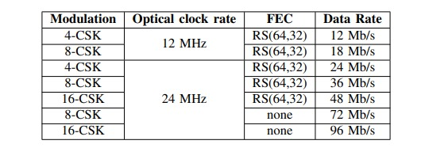

Table VII: PHY III in IEEE 802.15.7 Standard [12]

- *Peer-to-Peer*: In a peer-to-peer topology, devices can communicate with any other devices within their coverage area. One device acts as the coordinator, which can be assigned to the first device communicating in the channel.

- *Star*: In a star topology, there is a central controller (coordinator) that communicates with each device in the network. Every star network operates independently from others, identified by a unique network identifier.

- *Broadcast*: In this topology, one device can send information to others without forming a network. Communication is unidirectional.

Based on these topologies, IEEE 802.15.7 outlines several modulation techniques at the physical layer and specific protocols at the link layer. These will be covered in detail in Section IV.

1. **Physical and MAC Layers**

In this section, we discuss the physical and link layers in VLC systems. Researchers have studied how VLC integrates with the Internet, and we explore the main techniques used for light coding/decoding and modulation/demodulation, including CSK (Color Shift Keying), OOK (On-Off Keying), and OFDM (Orthogonal Frequency Division Multiplexing). We also examine access protocols like CSMA/CA, CSMA/CD, and CSMA/CD-HA in the Link layer.

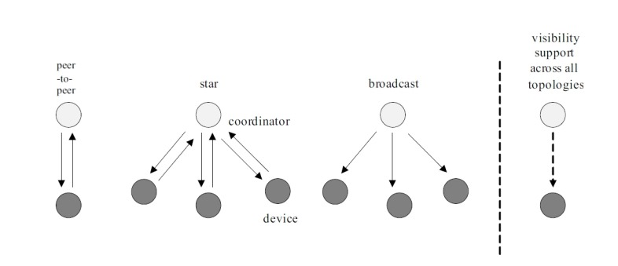

Fig-1. PHYSICAL AND MAC LAYERS

(5.1) **Physical Layer**

The Physical layer is responsible for transmitting data (bits) through a communication channel, such as twisted pair or radio waves. In VLC, light is used as the transmission medium. We discuss aspects of implementing the physical layer in VLC systems.

**Path Loss:** In VLC, LED light bulbs serve both illumination and communication purposes. The physical layer must consider the brightness requirements for successful communication. Light parameters determine brightness, color, and other aspects from a human vision perspective.

**Propagation:** Lightwave propagation is crucial in VLC. Indoor environments often have multiple transmitters (LEDs) and reflective surfaces, impacting VLC systems.

**Noise:** Noise is a significant concern for VLC, especially in outdoor environments where sunlight can cause interference. Filters can help prevent photo sensor saturation.

Light modulation is essential for VLC. It involves converting light intensity to digital signals to represent bits. Modulation techniques must balance high data rates with human perception of light (e.g., avoiding flickering). Here are some common modulation techniques:

**On-Off Keying (OOK):** OOK is a simple modulation method where bits 0 and 1 are represented by turning the LED on and off. This approach is widely used but may lead to flickering and limited data rates [62], [63].

**Variable Pulse Position Modulation (VPPM):** VPPM combines Pulse Position Modulation (PPM) and Pulse Width Modulation (PWM). PPM sets the digital value based on pulse position, while PWM sets the pulse length according to time [73].

**Color Shift Keying (CSK):** CSK modulates signals based on the intensity of three colors (red, green, blue) in multi-chip LEDs. This method increases data rates and uses the CIE 1931 chromaticity diagram [74].

**Orthogonal Frequency Division Multiplexing (OFDM):** OFDM divides the channel into multiple orthogonal sub-carriers, enabling modulated sub-streams on the sub-carriers. It helps reduce inter-symbol interference.

LEDs in VLC systems enable MIMO (Multiple-Input-Multiple-Output) communication since each LED can act as a transmitter. MIMO techniques, such as Repetition Coding, Spatial Multiplexing, and Spatial Modulation, aim to increase data rates, with some studies achieving speeds up to 1.1 Gbps [59].

The physical layer is a key part of VLC systems, considering the unique properties of visible light compared to radio frequency. Academic and standardization efforts work on resolving issues like modulation and coding mechanisms and their impact on oscillation and dimming of light.

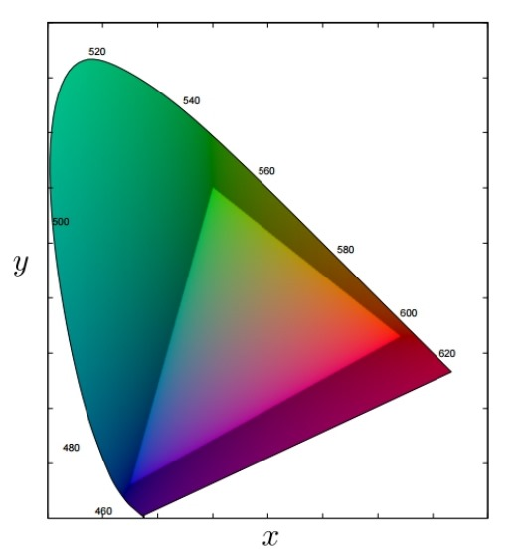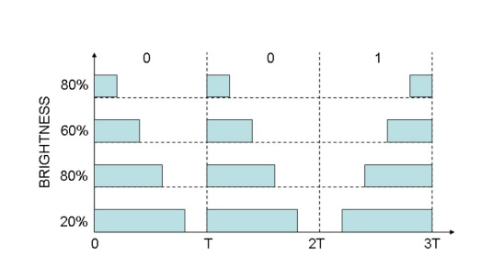

(a) Variable Pulse Position Modulation [12]

(b) CIE 1931 chromaticity diagram [38]

Figure 10: Modulations mechanisms proposed in the IEEE 802.15.7

(5.2) **MAC Layer**

Many VLC applications involve multiple access, where multiple transmitters and receivers share the same medium. In environments like corporate and residential buildings, multiple users may connect to a VLC access point (LED light bulb). Managing access to the medium, device association, and mobility is essential [21]. This section reviews traditional and new multiple access mechanisms in VLC.

**Time Division Multiple Access (TDMA):** TDMA divides the signal into time slots, allowing different users to share the same frequency channel without interference. This approach was common in early cellular networks and has been adapted for VLC. Kim et al. combined TDMA with optical beamforming in VLC to support multiple users over longer distances [77].

**Space Division Multiple Access (SDMA):** SDMA optimizes spectrum use by directing signals based on user positions. The directionality of VLC transmitters (LEDs) is well-suited for this method [78].

**Carrier Sense Multiple Access (CSMA):** The IEEE 802.15.7 standard includes two CSMA protocols. The first uses a random access channel without coordinator signals, requiring devices to wait for a back-off period before attempting to transmit. The second uses coordinator signals and divides time into intervals. Enhanced CSMA/CA and CSMA/CD-HA protocols have been implemented for better channel use and collision avoidance [79], [80].

**Orthogonal Frequency Division Multiple Access (OFDMA):** In OFDMA, users are allocated different subcarriers for communication. Challenges in VLC include energy efficiency and decoding complexity [81]. Recent research achieved data rates of up to 13.6 Mbps using OFDMA in VLC [82].

**Code Division Multiple Access (CDMA):** CDMA in VLC, also known as Optical CDMA (OCDMA), uses orthogonal optical codes (OOC) to allow different users to access the same channel. This method ensures optical efficiency but can reduce communication performance.

**Non-Orthogonal Multiple Access (NOMA):** NOMA was first introduced for 5G wireless networks [84]. It allows each user to use the entire bandwidth by allocating different power levels based on channel conditions. NOMA differs from traditional techniques by enabling full use of time and frequency resources. It uses superposition coding at the transmitter and successive interference cancellation (SIC) at the receiver.

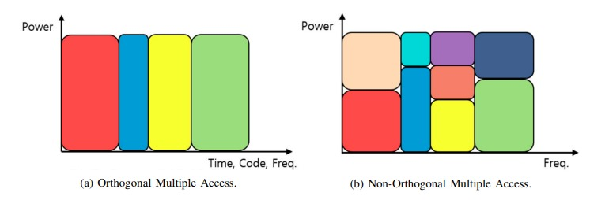

Recent research [88], [89], [90] highlights NOMA's potential in improving system performance, spectral efficiency, and user capacity in wireless technologies and VLC. In VLC, NOMA is seen as a promising approach to enhance performance, especially when applied to specific VLC scenarios [18], [19], [76].

1. **VLC Applications**

Visible Light Communication (VLC) offers various applications, including high-speed Internet access through LED lights and even interplanetary communication. Here, we discuss potential VLC applications, focusing on indoor systems, localization, underwater communication, and vehicular communication.

(6.1) **Indoor VLC System**

LED bulbs are widely used in homes and businesses, providing an existing infrastructure for VLC. This setup supports both illumination and communication, although it requires careful design to balance both functions [116]. Indoor VLC systems can also support applications such as localization [15].

(6.2) **Vehicular Communication**

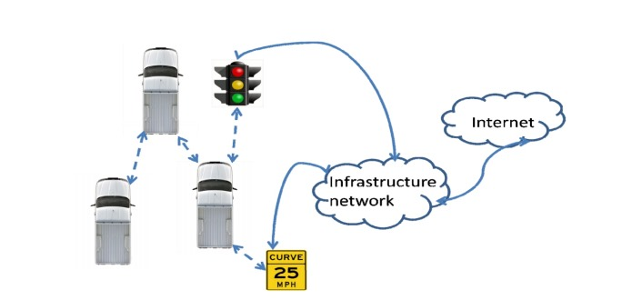

Figure 13: V2LC overview [127].

The use of VLC in vehicles leverages existing LED lights, such as car headlights and traffic signals, for communication. VLC can support intelligent transport systems (ITS), providing connectivity for Vehicle-to-Vehicle (V2V) and Vehicle-to Infrastructure (V2I) communications [126], [127], [128].

(6.3) **Indoor Positioning System**

VLC can provide high-precision indoor positioning by using signals from LED lights to calculate the receiver's location. Various techniques are used, including Received Signal Strength (RSS), Time of Arrival (TOA), and Angle of Arrival (AOA) [135].

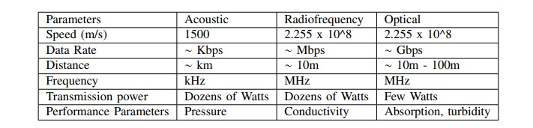(6.4) **Underwater Communication**

VLC is being explored for underwater communication, offering high data rates and low power consumption. Acoustic communication is most common underwater, but VLC provides higher bandwidth and can work in hybrid systems with acoustic communication [139], [140]. Optical communication faces challenges in underwater environments, such as light absorption and scattering by water [141].

Table XII: Comparison between types of underwater communications, adapted from [115]

Despite challenges, VLC offers promising solutions for various applications, with ongoing research addressing these issues and exploring innovative uses.

1. **Challenges**

Visible Light Communication (VLC) faces several challenges, ranging from issues specific to light (such as flickering, dimming, and line of sight) to common wireless communication problems like noise, interference, and mobility. Here, we discuss these challenges and potential solutions.

(7.1) **Line of Sight (LOS)**

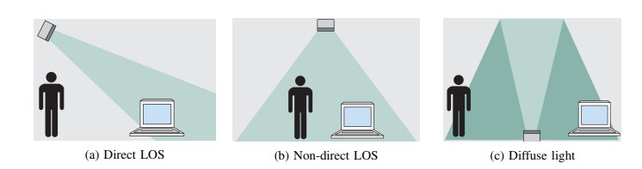

Figure 15: Visible Light Communication channel and light propagation, adapted from [147].

VLC systems typically require direct line of sight (LOS) between the user and the light source. In many indoor settings, lights are aimed at walls or covered by shades, affecting communication. Solutions involve using direct LOS for stronger signals or non-direct LOS and diffuse light for scenarios with limitations [71], [118], [147].

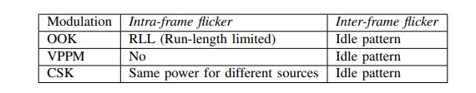(7.2) **Flickering**

Table XIII: Types of modulation and its flickering control methods.

Flickering refers to noticeable changes in light brightness and can occur due to certain modulation methods. It can cause discomfort to humans [148]. Solutions include avoiding frequencies below 3 kHz, as per the IEEE 802.15.7 standard [12]. Techniques such as Manchester encoding in On-Off Keying modulation help mitigate flickering [63].

(7.3) **Noise and Interference**

Natural and artificial lights can interfere with VLC communication, particularly outdoors. Interference can arise from different types of lights (LED, incandescent, and fluorescent) [150]. Optical filters and signal amplifiers can help mitigate this, as well as using specific types of receivers to filter out interference [151].

(7.4) **Dimming**

Dimming involves controlling light brightness according to user preferences. Lower light intensity can reduce communication range and data rates [162]. Modulation methods like On-Off Keying, Variable Pulse Position Modulation, and Color Shift Keying offer ways to control dimming [163].

(7.5) **Mobility**

VLC systems must support mobile devices, requiring mechanisms to maintain high-speed connections as users move [15], [164]. Approaches like angular diversity receivers and handover techniques enable better support for user mobility, allowing seamless transitions between coverage areas [165].

Addressing challenges related to signal coverage and mobility is crucial for VLC systems to become more commercially successful, especially in the consumer market.

1. **VLC Research Platforms**

Researchers have developed various open-source platforms to advance VLC studies. These platforms offer different hardware, software, and features, providing opportunities to experiment and improve VLC systems.

(8.1) **Shine**

Shine is a VLC system based on Arduino that uses off-the-shelf LEDs and resistors to establish communication. It reaches data rates up to 600 bps and works up to 3 meters [108]. Shine's platform supports 360-degree coverage by using multiple LEDs as transmitters and photodiodes as receivers. Its features include adaptive symbol thresholding, carrier sense implementation, and an API that offers three types of messages.

(8.2) **modBulb**

modBulb is an open-source VLC transmitter platform designed to serve as a research tool [166]. Its modular design allows for adaptation to user-specific requirements by adding different modules. The platform's baseband generator can be an MCU or FPGA, offering flexibility and high performance. It supports various modulations such as On-Off Keying and Pulse Position Modulation, with data transmission working well under ambient light.

(8.3) **iDropper**

iDropper is an early VLC system that uses LEDs as both transmitters and receivers [49]. It was designed as an alternative to RFID systems and can communicate at a rate of 250 bps. The protocol uses pulse-width modulated data and a synchronization mechanism where devices take turns flashing light to communicate.

(8.4) **DarkLight**

DarkLight is a VLC platform designed to provide communication while lights are off [48]. It uses Overlapping Pulse Position Modulation to encode data into small light pulses that are imperceptible to the human eye. Implemented with an FPGA, DarkLight achieves a data rate of 1.6 kbps at a distance of 1.3 meters. This platform uses a photodiode to sense ambient light and modify the LED duty cycle accordingly.

These VLC research platforms provide valuable tools for studying and developing VLC systems, contributing to the advancement of the field. They offer insights into the challenges and potential solutions for VLC communication in various scenarios.

1. **Advantages & Disadvantages**

(9.1) **Advantages**

1. Unlicensed Spectrum: VLC operates in the visible light range, which is free from the congestion and interference issues present in radio frequency (RF) bands.

2. Integration with Existing Infrastructure: VLC can leverage existing LED lighting infrastructure, combining lighting and communication in one system, which helps reduce costs and energy consumption.

3. Inherent Security: Since light signals do not penetrate walls, eavesdropping is more challenging, offering a level of privacy and security in communication.

4. High Data Rates: VLC systems, particularly those with direct line-of-sight (LOS), can offer fast and reliable data transmission, making them suitable for high-speed communication needs.

5. Energy Efficiency: VLC uses energy-efficient LED lights, contributing to overall system efficiency and supporting green technology initiatives.

(9.2) **Disadvantages**

1. Line-of-Sight Requirement: VLC relies heavily on line-of-sight (LOS) between the transmitter and receiver, limiting mobility and coverage compared to RF systems.

2. Flickering and Dimming: The modulation of light signals can cause flickering, leading to discomfort or health issues for users. Additionally, dimming can impact communication quality and range.

3. Noise and Interference: VLC systems may be affected by noise and interference from natural and artificial light sources, potentially degrading communication quality.

4. Coverage and Mobility Limitations: Achieving consistent coverage and mobility within VLC systems can be challenging, especially when users are moving or when there are obstacles in the environment.

1. **Conclusion and Discussions**

This study has delved into the principles, applications, and hurdles of Visible Light Communication (VLC). We've conducted a thorough review of the literature, analyzing current studies and projecting the future of VLC and intelligent illumination systems. VLC emerges as a promising solution for wireless communication, especially with the growing popularity of mobile devices and the consequent surge in demand for wireless connectivity. This trend is leading to a potential Wi-Fi spectrum crunch, where the need for wireless resources may soon exceed what the existing network infrastructure can provide.

VLC is particularly notable among the recent alternatives suggested to enhance wireless network infrastructures due to its significant benefits. The use of free spectrum, high frequencies, existing infrastructure, and LED light bulbs are compelling advantages that make visible light an attractive option. Nonetheless, there are still several challenges that hinder the commercialization of VLC-based technologies and applications, such as flickering, dimming control, uplink issues, and interference.

VLC presents an excellent opportunity to augment the existing wireless infrastructure, providing improved performance, particularly in short-distance environments like offices and homes. Moreover, it has potential applications in indoor positioning, underwater communication, and vehicular communication systems.

In conclusion, VLC represents a vast area of research that continues to garner interest from both academia and industry. Despite the progress made, the field requires further exploration, which is anticipated to continue in the coming years, driven by the growing popularity of concepts like the Internet of Things and intelligent lighting solutions.

1. **Comparative Analysis of My Research Paper with Others on VLC**

|  |  |  |
| --- | --- | --- |
| **Feature** | **My Research Paper** | **Other Research Papers** |
| Scope & Focus | Broad overview of challenges & solutions, applications & trends | May focus on specific technical aspects |
| Methodology | Different experimental setup, data collection & analysis | May use different approaches |
| Findings & Contributions | Aligns/diverges based on challenges & solutions discussed | May address different aspects of VLC |
| Practical Applications | Explores diverse applications (indoor & outdoor) | May focus on specific application areas |
| Depth of Analysis | In-depth analysis of challenges & solutions | May offer less detailed analysis |
| Future Directions | Focuses on standardization, hybrid systems & LED sensing | May highlight different future advancements |
| References & Citations | Wide range of sources, recent & foundational studies | May have a narrower range of citations |
| Overall | Comprehensive & detailed analysis, distinguishes from others | May offer more specific or focused approaches |

(12) **Reference**

[1] United States Department of Energy. Energy Savings Forecast ofSolid-State Lighting in General Illumination Applications. [Online].Available: <http://apps1.eere.energy.gov/buildings/publications/pdfs/ssl/energysavingsforecast14.pdf>

[2] Y. Tanaka, S. Haruyama, and M. Nakagawa, “Wireless optical transmissions with white colored LED for wireless home links,” in Proc. 11th IEEE Int. Symp. PIMRC, 2000, vol. 2, pp. 1325–1329.

[3] Visible Light Communications Consortium (VLCC). [Online]. Available: <http://www.vlcc.net/>

5] Infrared Data Association (IrDA). [Online]. Available: <http://www.irda.org>

[6] Home Gigabit Access (OMEGA) Project. [Online]. Available: <http://www.ict-omega.eu/>

[7] Visible Light Communications Association (VLCA). [Online]. Available: <http://vlca.net/>

[8] IEEE Standard for Local and Metropolitan Area Networks-Part 15.7:Short-Range Wireless Optical Communication Using Visible Light, IEEE Std. 802.15.7, Sep. 2011.

[15] Dilukshan Karunatilaka, Fahad Zafar, Vineetha Kalavally, and Rajendran Parthiban. Led based indoor visible light communications: State of the art. IEEE Communications Surveys and Tutorials, 17(3):1649–1678, 2015.

[21] Parth H Pathak, Xiaotao Feng, Pengfei Hu, and Prasant Mohapatra. Visible light communication, networking, and sensing: A survey, potential and challenges. ieee communications surveys & tutorials, 17(4):2047–2077, 2015.

[33] Shlomi Arnon. Visible light communication. Cambridge University Press, 2015.

[12] Ieee standard for local and metropolitan area networks–part 15.7: Short-range wireless optical communication using visible light. IEEE Std 802.15.7-2011, pages 1–309, Sept 2011.

[49] Paul Dietz, William Yerazunis, and Darren Leigh. Very low-cost sensing and communication using bidirectional leds. In UbiComp 2003: Ubiquitous Computing, pages 175–191. Springer, 2003.

[50] Hyunchae Chun, Sujan Rajbhandari, Grahame Faulkner, Dobroslav Tsonev, Harald Haas, and Dominic O’Brien. Demonstration of a bidirectional visible light communication with an overall sum-rate of 110 mb/s using leds as emitter and detector. In Photonics Conference (IPC), 2014 IEEE, pages 132–133. IEEE, 2014

[51] Dong-Yong Shin, Jae Young Kim, and In-Yong Eom. Spectral responses of light-emitting diodes as a photodiode and their applications in optical measurements. Bulletin of the Korean Chemical Society, 37(12):2041–2046, 2016.

[52] Luiz Matheus, Letícia Pires, Alex Vieira, Luiz F. M. Vieira, Marcos A. M. Vieira, and José A. Nacif. The internet of light: Impact of colors in led-to-led visible light communication systems. Internet Technology Letters, 0(00):1–6, 2018.

[23] Svilen Dimitrov and Harald Haas. Principles of LED Light Communications: Towards Networked Li-Fi. Cambridge University Press, 2015.

[53] Moussa Ayyash, Hany Elgala, Abdallah Khreishah, Volker Jungnickel, Thomas Little, Sihua Shao, Michael Rahaim, Dominic Schulz, Jonas Hilt, and Ronald Freund. Coexistence of wifi and lifi toward 5g: Concepts, opportunities, and challenges. IEEE Communications Magazine, 54(2):64–71, 2016.

[55] Qing Wang, Domenico Giustiniano, and Omprakash Gnawali. Low-cost, flexible and open platform for visible light communication networks. In Proceedings of the 2nd International Workshop on Hot Topics in Wireless, pages 31–35. ACM, 2015.

[54] Harald Burchardt, Nikola Serafimovski, Dobroslav Tsonev, Stefan Videv, and Harald Haas. Vlc: Beyond point-to-point communication. IEEE Communications Magazine, 52(7):98–105, 2014.

[57] Christian Rohner, Shahid Raza, Daniele Puccinelli, and Thiemo Voigt. Security in visible light communication: Novel challenges and opportunities. Sensors & Transducers, 192(9):9, 2015.

[58] Christopher J Hansen. Wigig: Multi-gigabit wireless communications in the 60 ghz band. IEEE Wireless Communications, 18(6), 2011.

[59] Ahmad Helmi Azhar, T Tran, and Dominic O’Brien. A gigabit/s indoor wireless transmission using mimo-ofdm visible-light communications. IEEE Photonics Technology Letters, 25(2):171–174, 2013.

[60] Ariel Gomez, Kai Shi, Crisanto Quintana, Masaki Sato, Grahame Faulkner, Benn C Thomsen, and Dominic O’Brien. Beyond 100-gb/s indoor wide field-of-view optical wireless communications. IEEE Photon. Technol. Lett., 27(4):367–370, 2015.

[32] Stefan Schmid, Giorgio Corbellini, Stefan Mangold, and Thomas R Gross. Led-to-led visible light communication networks. In Proceedings of the fourteenth ACM international symposium on Mobile ad hoc networking and computing, pages 1–10. ACM, 2013.

[66] Latif Ullah Khan. Visible light communication: Applications, architecture, standardization and research challenges. Digital Communications and Networks, 2016.

[67] Stefan Schmid, Thomas Richner, Stefan Mangold, and Thomas R Gross. Enlighting: An indoor visible light communication system based on networked light bulbs. In Sensing, Communication, and Networking (SECON), 2016 13th Annual IEEE International Conference on, pages 1–9. IEEE, 2016.

[16] Carlos Medina, Mayteé Zambrano, and Kiara Navarro. Led based visible light communication: Technology, applications and challenges-a survey. International Journal of Advances in Engineering & Technology, 8(4):482, 2015.

[68] Kaiyun Cui, Gang Chen, Zhengyuan Xu, and Richard D Roberts. Traffic light to vehicle visible light communication channel characterization. Applied optics, 51(27), 2012.

[69] Shinichiro Haruyama. Japan’s visible light communications consortium and its standardization activities. <https://mentor.ieee.org/802.15/> dcn/08/15-08-0061-00-0vlc-japan-s-visible-%20light-communications-consortium-and-its.pdf, 2010.

[70] Andrew S Tanenbaum et al. Computer networks, 4-th edition. ed: Prentice Hall, 2003.

[12] Ieee standard for local and metropolitan area networks–part 15.7: Short-range wireless optical communication using visible light. IEEE Std 802.15.7-2011, pages 1–309, Sept 2011.

[73] Hany Elgala, Raed Mesleh, and Harald Haas. Indoor optical wireless communication: potential and state-of-the-art. IEEE Communications Magazine, 49(9), 2011.

[74] János Schanda. Colorimetry: understanding the CIE system. John Wiley & Sons, 2007.

[38] Eric Monteiro and Steve Hranilovic. Design and implementation of color-shift keying for visible light communications. Journal of Lightwave Technology, 32(10):2053–2060, 2014.

[77] Sung-Man Kim, Myeong-Woon Baek, and Seung Hoon Nahm. Visible light communication using tdma optical beamforming. EURASIP Journal on Wireless Communications and Networking, 2017(1):56, 2017.

[78] Zhe Chen and Harald Haas. Space division multiple access in visible light communications. In Communications (ICC), 2015 IEEE International Conference on, pages 5115–5119. IEEE, 2015.

[79] Qing Wang and Domenico Giustiniano. Communication networks of visible light emitting diodes with intra-frame bidirectional transmission. In Proceedings of the 10th ACM International on Conference on emerging Networking Experiments and Technologies, pages 21–28. ACM, 2014.

[80] Qing Wang and Domenico Giustiniano. Intra-frame bidirectional transmission in networks of visible leds. IEEE/ACM Transactions on Networking (TON), 24(6):3607–3619, 2016.

[81] Jian Dang and Zaichen Zhang. Comparison of optical ofdm-idma and optical ofdma for uplink visible light communications. In IEEE WCSP, pages 1–6, 2012

[82] Jiun-Yu Sung, Chien-Hung Yeh, Chi-Wai Chow, Wan-Feng Lin, and Yang Liu. Orthogonal frequency-division multiplexing access (ofdma) based wireless visible light communication (vlc) system. Optics Communications, 355:261–268, 2015.

[84] Anass Benjebbour, Yuya Saito, Yoshihisa Kishiyama, Anxin Li, Atsushi Harada, and Takehiro Nakamura. Concept and practicalconsiderations of non-orthogonal multiple access (noma) for future radio access. In Intelligent Signal Processing and CommunicationsSystems (ISPACS), 2013 International Symposium on, pages 770–774. IEEE, 2013.

[88] Zhiqiang Wei, Jinhong Yuan, Derrick Wing Kwan Ng, Maged Elkashlan, and Zhiguo Ding. A survey of downlink non-orthogonal multiple access for 5g wireless communication networks. arXiv preprint arXiv:1609.01856, 2016.

[89] SM Riazul Islam, Nurilla Avazov, Octavia A Dobre, and Kyung-Sup Kwak. Power-domain non-orthogonal multiple access (noma) in 5g systems: Potentials and challenges. IEEE Communications Surveys & Tutorials, 19(2):721–742, 2017.

[90] Linglong Dai, Bichai Wang, Zhiguo Ding, Zhaocheng Wang, Sheng Chen, and Lajos Hanzo. A survey of non-orthogonal multiple access for 5g. IEEE Communications Surveys & Tutorials, 20(3):2294–2323, 2018.

[76] Sarah S Bawazir, Paschalis C Sofotasios, Sami Muhaidat, Yousof Al-Hammadi, and George K Karagiannidis. Multiple access for visible light communications: Research challenges and future trends. IEEE Access, 2018.

[18] Mohanad Obeed, Anas M Salhab, Mohamed-Slim Alouini, and Salam A Zummo. On optimizing vlc networks for downlink multi-user transmission: A survey. arXiv preprint arXiv:1808.05089, 2018.

[19] Saad Al-Ahmadi, Omar Maraqa, Murat Uysal, and Sadiq M Sait. Multi-user visible light communications: State-of-the-art and future directions. IEEE Access, 6:70555–70571, 2018.

[116] Dominic O’Brien, Hoa Le Minh, Lubin Zeng, Grahame Faulkner, Kyungwoo Lee, Daekwang Jung, YunJe Oh, and Eun Tae Won. Indoorvisible light communications: challenges and prospects. In Optical Engineering+ Applications, pages 709106–709106. International Society for Optics and Photonics, 2008.

[127] Cen B Liu, Bahareh Sadeghi, and Edward W Knightly. Enabling vehicular visible light communication (v2lc) networks. In Proceedings of the Eighth ACM international workshop on Vehicular inter-networking, pages 41–50. ACM, 2011.

[126] Panos Papadimitratos, Arnaud De La Fortelle, Knut Evenssen, Roberto Brignolo, and Stefano Cosenza. Vehicular communication systems: Enabling technologies, applications, and future outlook on intelligent transportation. IEEE Communications Magazine, 47(11), 2009.

[128] Masako Akanegawa, Yuichi Tanaka, and Masao Nakagawa. Basic study on traffic information system using led traffic lights. IEEE Transactions on Intelligent Transportation Systems, 2(4):197–203, 2001.

[135] Liqun Li, Pan Hu, Chunyi Peng, Guobin Shen, and Feng Zhao. Epsilon: A visible light based positioning system. In NSDI, pages 331–343, 2014.

[115] Hemani Kaushal and Georges Kaddoum. Underwater optical wireless communication. IEEE Access, 4:1518–1547, 2016.

[139] Ian C Rust and H Harry Asada. A dual-use visible light approach to integrated communication and localization of underwater robots with application to non-destructive nuclear reactor inspection. In Robotics and Automation (ICRA), 2012 IEEE International Conference on, pages 2445–2450. IEEE, 2012.

[140] Seongwon Han, Youngtae Noh, Richard Liang, Roy Chen, Yung-Ju Cheng, and Mario Gerla. Evaluation of underwater optical-acoustic hybrid network. China Communications, 11(5):49–59, 2014.

[141] Liu Lanbo, Zhou Shengli, and Cui Jun-Hong. Prospects and problems of wireless communication for underwater sensor networks. Wireless Communications and Mobile Computing, 8(8):977–994, 2008.

[147] Liane Grobe, Anagnostis Paraskevopoulos, Jonas Hilt, Dominic Schulz, Friedrich Lassak, Florian Hartlieb, Christoph Kottke, Volker Jungnickel, and Klaus-Dieter Langer. High-speed visible light communication systems. IEEE Communications Magazine, 51(12):60–66, 2013

[71] Kaiyun Cui, Gang Chen, Zhengyuan Xu, and Richard D Roberts. Line-of-sight visible light communication system design and demonstration. In IEEE CSNDSP, 2010.

[118] Toshihiko Komine and Masao Nakagawa. Fundamental analysis for visible-light communication system using led lights. IEEE trans. On Consumer Electronics, 50(1):100–107, 2004.

[148] Arnold Wilkins, Jennifer Veitch, and Brad Lehman. Led lighting flicker and potential health concerns: Ieee standard par1789 update. In Energy Conversion Congress and Exposition (ECCE), 2010 IEEE, pages 171–178. IEEE, 2010.

[150] Adriano JC Moreira, Rui T Valadas, and AM de Oliveira Duarte. Optical interference produced by artificial light. Wireless Networks, 3(2):131–140, 1997.

[151] J-H Yoo, J-S Jang, JK Kwon, H-C Kim, D-W Song, and S-Y Jung. Demonstration of vehicular visible light communication based on led headlamp. International journal of automotive technology, 17(2):347–352, 2016.

[162] Zixiong Wang, Wen-De Zhong, Changyuan Yu, Jian Chen, Chin Po Shin Francois, and Wei Chen. Performance of dimming control scheme in visible light communication system. Optics express, 20(17):18861–18868, 2012.

[163] Bo Bai, Zhengyuan Xu, and Yangyu Fan. Joint led dimming and high capacity visible light communication by overlapping ppm. In Wireless and Optical Communications Conference (WOCC), 2010 19th Annual, pages 1–5. IEEE, 2010.

[164] Jialiang Zhang, Xinyu Zhang, and Gang Wu. Dancing with light: Predictive in-frame rate selection for visible light networks. In Computer Communications (INFOCOM), 2015 IEEE Conference on, pages 2434–2442. IEEE, 2015.

[165] Andrew Burton, Zabih Ghassemlooy, Sujan Rajbhandari, and Shien-Kuei Liaw. Design and analysis of an angular-segmented full-mobility visible light communications receiver. Transactions on Emerging Telecommunications Technologies, 25(6):591–599, 2014.

[108] Lennart Klaver and Marco Zuniga. Shine: A step towards distributed multi-hop visible light communication. In Mobile Ad Hoc and Sensor Systems (MASS), 2015 IEEE 12th International Conference on, pages 235–243. IEEE, 2015

[166] Kasun Hewage, Ambuj Varshney, Abdalah Hilmia, and Thiemo Voigt. modbulb: a modular light bulb for visible light communication. In Proceedings of the 3rd Workshop on Visible Light Communication Systems, pages 13–18. ACM, 2016.

[48] Harald Haas, Liang Yin, Yunlu Wang, and Cheng Chen. What is lifi? Journal of Lightwave Technology, 34(6):1533–1544, 2016.